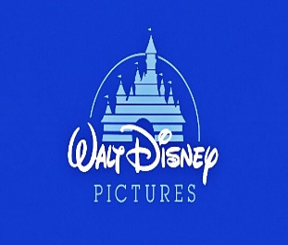  This Photo by Unknown Author is licensed under CC BY | Walt Disney  animation studio
Phone |  | Mira Karlsson
Email |  | [chief executive officer]
City / State / Country |  | Walt Disney animation studio
 LinkedIn |  | Oxford house Tamiko place 979 king’s road
 Skype |  | Quarry bay, Hong Kong
 Website

Dear mira karlsson
Are you looking for an animator with?
- 2 years of hands – on experience in character design and 2d 3d movement?
- Knowledge of the latest technology in adobe animate?
- A passion to learn and to increase my technical and creative skills?
If so, then you need look no further. You will see from my enclosed resume that I meet all of these qualifications and more.
I would very much like to discuss opportunities with the Walt Disney company to schedule an interview, please call me at 9403036302 The best time to reach me is between 9 am to 5pm but you can leave a voice message at any time, and I will return your call."

Thank you for taking the time to review my resume. I look forward to talking with you.

Sincerely,

Josh butler

